*Chilled Asparagus and Almond Soup*

The combined goodness of antioxidant-rich asparagus and protein-packed almonds makes this a superfood soup. Enjoy hot or chilled, just don’t skimp on the lemon zest – it really lifts the creaminess and richness.

**DFNFVEGANVGF**

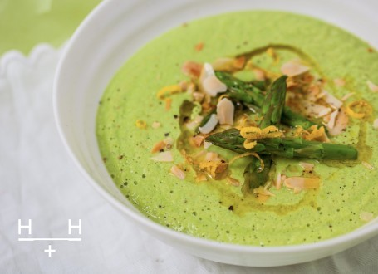

*How To*

1. Toast 25g of the almonds in a dry, large saucepan and set aside for garnishing later.
2. In the same pan gently fry the onion and leek in ghee for 5 minutes until softened, but not browned. Add the garlic and tarragon to the pan and fry for another minute.
3. Prepare the asparagus by snapping off the woody ends. Add the spears and remaining 75g almonds to the pan. Stir, add a pinch of salt and black pepper, then add the stock.
4. Simmer gently for 5 minutes, with the lid on, until the asparagus is tender.
5. Remove from the heat and add the lemon juice. Blend carefully, in batches if necessary. Taste and adjust the seasoning.
6. Serve in warmed bowls and scatter the toasted, flaked almonds on top with lemon zest and a swirl of extra virgin olive oil. Alternatively, chill and remove from the fridge just before serving, then garnish as above. For NF version, substitute with pumpkin and/or sunflower seeds.

[*Published in The Guardian, Cook, May 2013*](http://www.theguardian.com/lifeandstyle/2013/may/25/10-best-recipes-asparagus)

*Ingredients*

Serves 4

* 100g flaked almonds. For NF version, substitute with pumpkin and/or sunflower seeds.
* 1 small onion, roughly diced
* 1 large leek, roughly diced
* 1 tsp ghee
* 1 large garlic clove, roughly diced
* 2½ tsp fresh tarragon, chopped (or 1 tsp dried)
* 600g asparagus, trimmed
* 1¼ litres [homemade chicken bone broth](http://www.hemsleyandhemsley.com/recipe/bone-broth/) (or good-quality vegetable stock) - if you can't make your own buy organic, gluten-free stock (check for unwanted ingredients on the label)
* 2½ tsp fresh lemon juice
* Salt and black pepper

*For The Topping*

* ½ tsp lemon zest
* ½ tbsp extra virgin olive oil